STUDENT MANAGER APP 2 DEVELOPMENT LOGBOOK
Student Name: Hamdi Abdi
Registration Number: _BIT/2023/63327_____________________
Course: Bachelor of Science in Information Technology (BIT)
Unit Code: BIT 4107
Unit Name: Mobile Application Development
Project Title: Student Manager App 2

Activity 1: Login Screen

Objective
The objective of this activity was to design and implement a secure and user-friendly login interface for the Student Manager App 2. The login screen was developed to allow authorized users to enter their username and password before accessing the system. This feature improves the security of the application by preventing unauthorized access and serves as the entry point to all other functionalities of the application.
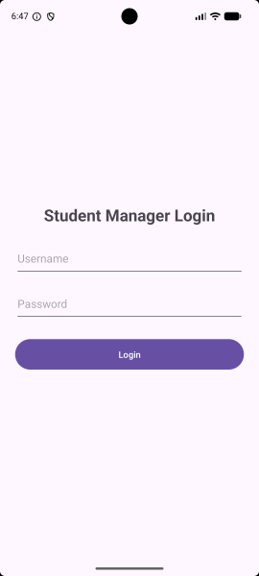Evidence

Activity 2: Dashboard

Objective
The objective of this activity was to develop the main dashboard of the Student Manager App 2. The dashboard serves as the central navigation point of the application by providing users with easy access to all available modules such as adding students, viewing records, updating information, deleting records, searching students, generating reports, and accessing the About page. The dashboard was designed to improve usability by making navigation simple and efficient.
Evidence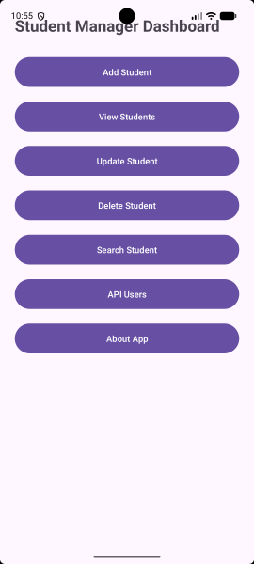

Activity 3: Add Student

Objective
The objective of this activity was to implement the Add Student functionality, allowing users to capture and store new student information in the SQLite database. The feature collects student details through input fields, validates the entered information, and saves the records permanently in the local database. This functionality forms the foundation of the application's data management process.
Evidence
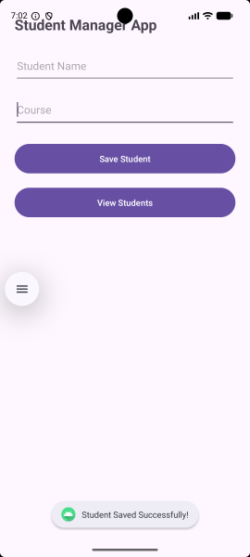

Activity 4: View Students

Objective
The objective of this activity was to retrieve and display all student records stored in the SQLite database. This functionality enables users to access previously saved information in an organized list, making it easier to verify stored records, monitor student information, and prepare the records for further operations such as updating, deleting, or searching.
Eviden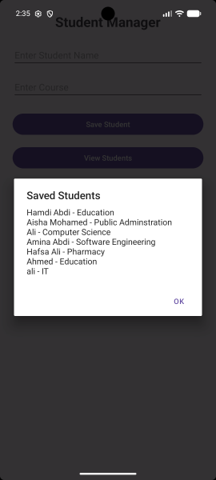ce

Activity 5: Update Student

Objective
The objective of this activity was to implement functionality that allows users to modify existing student records stored in the database. The feature enables correction of inaccurate information and updating of student details whenever changes occur. This ensures that the database maintains accurate, current, and reliable information throughout the application's usage.
Evidence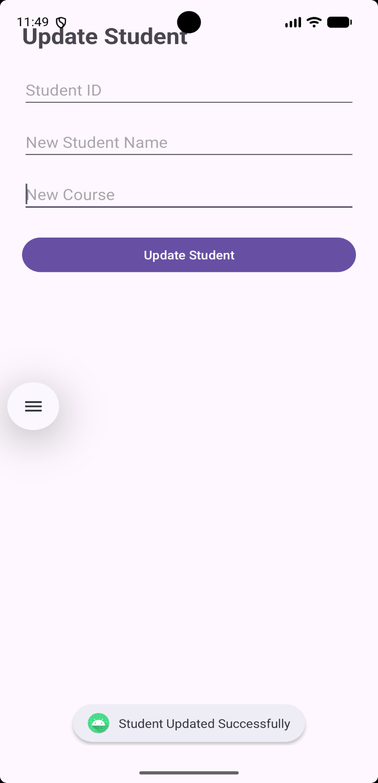

Activity 6: Delete Student

Objective
The objective of this activity was to implement the Delete Student functionality, enabling users to permanently remove unwanted or obsolete student records from the SQLite database. This feature helps maintain an organized database by eliminating duplicate, incorrect, or unnecessary records while ensuring efficient database management.
Evidence) 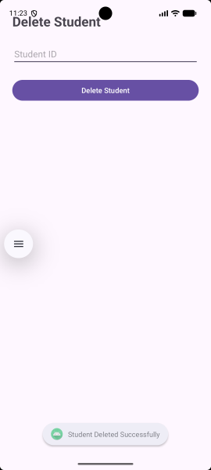

Activity 7: Search Student

Objective
The objective of this activity was to develop a search functionality that allows users to quickly locate specific student records using relevant search criteria such as names or identification details. The feature improves the efficiency of the application by reducing the time required to locate individual records within a large database.
Evidencet Searcht 

Activity 8: Reports

Objective
The objective of this activity was to create a reports module capable of presenting student information in a clear and organized manner. The reports section provides users with summarized information generated from the database, making it easier to review stored data and support informed decision-making based on the available records.
Evidence) 

Activity 9: API Integration

Objective
The objective of this activity was to integrate an Application Programming Interface (API) into the Student Manager App 2 to enable communication between the application and external services. The integration demonstrates the application's ability to exchange data efficiently with external systems while enhancing its functionality beyond local database operations.
Evidence
(Insert API Integration Screenshot Here)

Activity 10: About Page

Objective
The objective of this activity was to design and implement an About page that provides users with information about the Student Manager App 2, including its purpose, functionality, and developer details. The page was created to improve user understanding of the application while providing reference information regarding the system and its development.
Evidence


Conclusion
The Student Manager App 2 was successfully designed and developed using Android Studio as part of the Mobile Application Development course. The application incorporates user authentication, a dashboard for easy navigation, SQLite database integration for data storage, complete CRUD (Create, Read, Update and Delete) operations, search functionality, API integration, reports generation, an About page, and event handling techniques. Throughout the development process, the application was tested to ensure that all features functioned correctly. The project enhanced practical knowledge in Android application development, database management, API integration, user interface design, and software testing while demonstrating the ability to develop a complete mobile application from design to implementation.

